Introduction to .NET Framework

**.NET**is a software framework which is designed and developed by Microsoft. The first version of .Net framework was 1.0 which came in the year 2002. In easy words, it is a virtual machine for compiling and executing programs written in different languages like [C#](https://www.geeksforgeeks.org/introduction-to-c/), VB.Net etc.  
It is used to develop Form-based applications, Web-based applications, and Web services. There is a variety of programming languages available on the .Net platform, VB.Net and [C#](https://www.geeksforgeeks.org/introduction-to-c/) being the most common ones are

* C#.NET
* VB.NET
* C++.NET
* J#.NET
* F#.NET
* JSCRIPT.NET
* WINDOWS POWERSHELL
* IRON RUBY
* IRON PYTHON
* C OMEGA
* ASML(Abstract State Machine Language)

It is used to build applications for Windows, phone, web etc. It provides a lot of functionalities and also supports industry standards.

.NET Framework supports more than 60 programming languages in which 11 programming languages are designed and developed by Microsoft. The remaining [**Non-Microsoft Languages**](https://bitbucket.org/brianritchie/wiki/wiki/.NET%20Languages) which are supported by .NET Framework but not designed and developed by Microsoft.

**11 Programming Languages which are designed and developed by Microsoft are:**

* C#.NET
* VB.NET
* C++.NET
* J#.NET
* F#.NET
* JSCRIPT.NET
* WINDOWS POWERSHELL
* IRON RUBY
* IRON PYTHON
* C OMEGA
* ASML(Abstract State Machine Language)

**Main Components of .NET Framework**

[**Common Language Runtime(CLR)**](https://www.geeksforgeeks.org/common-language-runtime-clr-in-c/)**:** CLR is the basic and Virtual Machine component of the .NET Framework. It is the run-time environment in the .NET Framework that runs the codes and helps in making the development process easier by providing the various services such as remoting, thread management, type-safety, memory management, robustness etc.. Basically, it is responsible for managing the execution of .NET programs regardless of any .NET programming language. It also helps in the management of code, as code that targets the runtime is known as the Managed Code and code doesn’t target to runtime is known as Unmanaged code.

**Framework Class Library(FCL):** It is the collection of reusable, object-oriented class libraries and methods etc that can be integrated with CLR. Also called the Assemblies. It is just like the header files in C/C++ and packages in the java. Installing .NET framework basically is the installation of CLR and FCL into the system. Below is the overview of .NET Framework

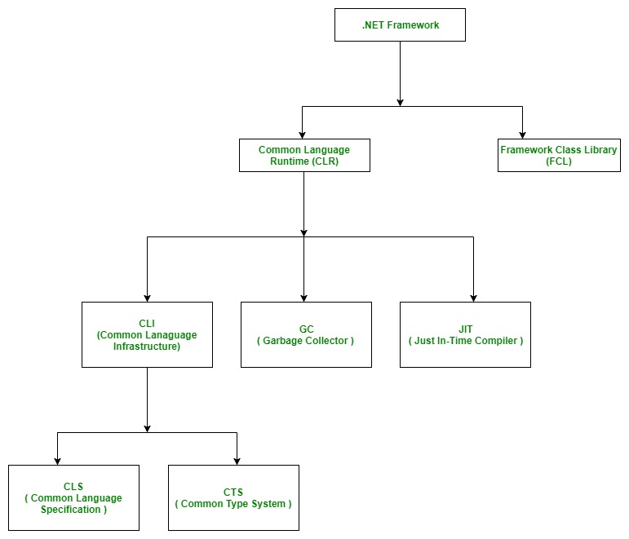

**Is .NET application platform dependent or platform independent?**

The combination of *Operating System Architecture and CPU Architecture* is known as the platform. Platform dependent means the programming language code will run only on particular Operating System. A *.NET application is platform dependent* because of the .NET framework which is only able to run on the Windows-based operating system. The .Net application is platform independent also because of *Mono framework*. Using Mono framework the .Net application can run on any Operating System including windows. Mono framework is a third party software developed by [**Novell Company**](https://www.microfocus.com/novell/) which is now a part of [**Micro Focus Company**](https://www.microfocus.com/novell/). It is a paid framework.

**Important Points:**

* Visual Studio is the development tool which is used to design and develop the .NET applications. For using Visual Studio, the user has to first install the .NET framework on the system.
* In the older version of Windows OS like XP SP1, SP2 or SP3, .NET framework was integrated with the installation media.
* Windows 8, 8.1 or 10 do not provide a pre-installed version 3.5 or later of .NETFramework. Therefore, a version higher than 3.5 must be installed either from a Windows installation media or from the Internet on demand. Windows update will give recommendations to install the .NET framework.